FEEL THE BEAT CPR
HELPFUL REMINDERS

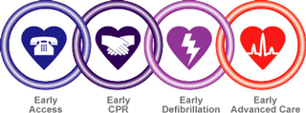

Remember:
THE CHAIN OF SURVIVAL
- Early access to Emergency services
- Early CPR
- Early Defibrillation and access to an AED
- Early advanced care (paramedics) arrive on scene
A breakdown in any of the chains diminishes the chances of survival for the victim!
Remember:
CPR
- Always use your mouth to mask barrier device if available
- If you do not have a barrier device and you do not feel comfortable doing mouth to mouth rescue breathing, you can do compressions only
- 30 compression and 2 breaths (15:2 for infant and child if two rescuers are present)
- 100 compressions per minute
- 5 cycles of CPR should equal 2 minutes of CPR
- Re-evaluate your victims heart rate and breathing after 5 cycles (if you are not a healthcare provider then re-assessing the pulse is not necessary)

- If you suspect the victim is a trauma or may have a spinal injury, remember to use the ‘jaw thrust’ rather than the ‘head tilt/chin lift’
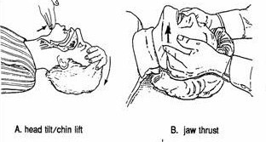

Remember:
INFANT/CHILD
- Never use an AED on an infant
- Infants are categorized as being birth to 1 year
- Child or infant witnessed arrest - you can notify EMS and grab an AED first before you start CPR-remember NO AED on an infant
- Child or infant unwitnessed arrest – always start CPR first as you do not know how long they have been there and do 5 cycles of CPR, then call EMS and grab an AED and continue with CPR
- A child is considered 1 yr to 8yrs old – if in health care 1yr to puberty
Remember:
AED
- There are pads for a child and pads for an adult for most AED’s
- There are only 2 buttons, one to turn the AED on and the other to shock, some will turn on when you open up the cover
- Never stop CPR until your pads are in place and the AED is analyzing the rhythm. Once it has analyzed the rhythm, it will tell you if shock is advised and if so, will tell you to stay clear of the victim, then to push the button to shock.
- The AED will then prompt you to continue with CPR

Remember:
INFANT CHOKING
- Never do a blind sweep of the mouth
- Place child prone on lap facing downward and give 5 downward back slaps
- Cradle the child’s head and flip the child over and do 5 chest thrusts
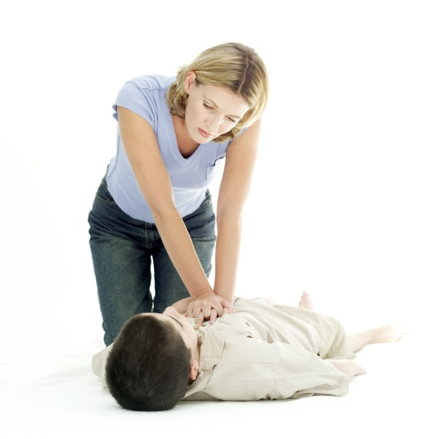
- Continue until the object comes out or the child goes unconscious at which point you would start CPR
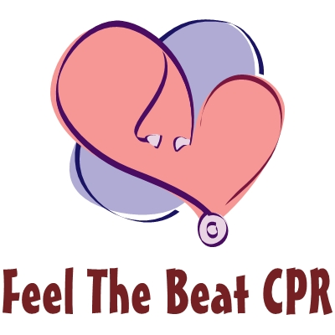

Remember to “Feel the Beat” and do your compressions to the beat of “Stayin’ Alive” by the Bee Gee’s to keep the victim “Stayin’ Alive”!


I- I- I- I ….Stayin’ Alive…. Stayin’ Alive!!
………..You can do it!
Celina and Monica
905-637-5490

